Supplementary Information

Table S1 Dataset of SARS-CoV-2 S protein sequences downloaded

|  |  |  |  |  |  |  |
| --- | --- | --- | --- | --- | --- | --- |
| Time period | Africa (case/variant) | Asia  (case/variant) | Europe  (case/variant) | North America  (case/variant) | Oceania  (case/variant) | South America  (case/variant) |
| Jan-Mar, 2020 | 94/13 | 2,274/214 | 1,406/104 | 10,055/400 | 854/64 | 149/15 |
| Apr-Jun, 2020 | 778/105 | 2,808/347 | 1,444/126 | 19,662/968 | 977/68 | 410/44 |
| Jul-Sep, 2020 | 645/100 | 2,100/242 | 1,675/145 | 18,434/1,159 | 8,240/229 | 116/32 |
| Oct-Dec, 2020 | 1,192/268 | 2,661/348 | 1,885/224 | 45,478/3,264 | 425/63 | 319/95 |
| Jan-Mar, 2021 | 1,589/393 | 1,248/323 | 3,319/451 | 140,838/10,916 | 98/36 | 356/138 |
| Apr-Jun, 2021 | 1,447/358 | 2,157/469 | 1,584/359 | 177,356/11,233 | 61/23 | 2,273/489 |
| Jul-Sep, 2021 | 1,933/491 | 4,703/812 | 3,416/546 | 382,456/21,392 | 2,017/47 | 4,771/824 |
| Oct-Dec, 2021 | 1,281/235 | 3,969/730 | 3,069/617 | 461,734/25,974 | 2,551/92 | 4,147/760 |
| Jan-Mar, 2022 | 720/95 | 8,648/727 | 1,939/271 | 247,674/9,632 | 2,611/119 | 1,948/140 |
| Apr-Jun, 2022 | 854/157 | 2,777/367 | 2,168/300 | 261,252/8,397 | 2,603/217 | 88/30 |
| Jul-Sep, 2022 | 298/75 | 4,178/605 | 1,162/214 | 253,298/11,225 | 2/2 | 106/32 |
| Oct-Dec, 2022 | 250/61 | 2,268/534 | 379/144 | 147,966/11,044 | 18/6 | 17/5 |
| Jan-Mar, 2023 | 35/21 | 1,087/324 | 121/64 | 90,796/8,895 | / | 49/24 |
| Apr-Jun, 2023 | 11/7 | 908/301 | 146/74 | 22,424/3,707 | / | 76/38 |
| Jul-Sep, 2023 | 4/3 | 667/317 | 44/31 | 38,369/5,797 | / | / |
| Oct-Dec, 2023 | / | 313/156 | 180/101 | 44,399/6,486 | / | / |
| Jan-Mar, 2024 | / | 160/79 | 43/17 | 26,275/3,216 | / | / |
| Apr-May, 2024 | / | 10/9 | / | 2,170/543 | / | / |
| Subtotal | 11,131/2,382 | 43,249/6,904 | 23,980/3,788 | 2,390,636/144,248 | 20,457/966 | 14,825/2,604 |
| Total | 2,504,278/160,892*，including 135,492 unique variant sequences. | | | | | |

* The variant number is the result of accumulation over time periods, so the real variants are smaller than this number.

Table S2 Profiles of SARS-cov-2 variants in Africa: lineage, mutation details, Fitness, and IEIs

|  |  |  |  |  |  |  |  |  |  |
| --- | --- | --- | --- | --- | --- | --- | --- | --- | --- |
|  | Case /  Variant sequence | Dominant Lineage | Dominant Percentage* | Unique  Lineages | MMut | MaxFit | MFit | MaxIEI | MIEI |
| Jan-Mar, 2020 | 94/13 | B.1 | 30.77% | 9 | 2 | 0.213 | 0.204 | 0.168 | 0.156 |
| Apr-Jun, 2020 | 778/105 | B.1 | 32.38% | 29 | 2 | 0.306 | 0.207 | 0.299 | 0.158 |
| Jul-Sep, 2020 | 645/100 | B.1 | 34.0% | 28 | 2 | 0.283 | 0.210 | 0.349 | 0.163 |
| Oct-Dec, 2020 | 1,192/268 | B.1 | 23.51% | 54 | 9 | 0.370 | 0.228 | 0.350 | 0.204 |
| Jan-Mar, 2021 | 1,580/393 | B.1.1.7 | 20.36% | 48 | 9 | 0.372 | 0.257 | 0.369 | 0.253 |
| Apr-Jun, 2021 | 1,447/358 | B.1.1.7 | 22.91% | 39 | 11 | 0.376 | 0.299 | 0.371 | 0.264 |
| Jul-Sep, 2021 | 1,933/491 | AY.36 | 23.63% | 50 | 11 | 0.388 | 0.356 | 0.350 | 0.241 |
| Oct-Dec, 2021 | 1,281/235 | B.1.617.2 | 14.89% | 54 | 12 | 0.738 | 0.397 | 0.415 | 0.262 |
| Jan-Mar, 2022 | 720/95 | BA.1.1 | 37.89% | 25 | 38 | 0.771 | 0.513 | 0.437 | 0.308 |
| Apr-Jun, 2022 | 854/157 | BA.2 | 24.20% | 30 | 33 | 0.737 | 0.643 | 0.415 | 0.363 |
| Jul-Sep, 2022 | 298/75 | BA.5.2.1 | 16.00% | 33 | 35 | 0.831 | 0.676 | 0.472 | 0.380 |
| Oct-Dec, 2022 | 250/61 | BQ.1.1 | 22.95% | 26 | 38 | 0.813 | 0.751 | 0.459 | 0.424 |
| Jan-Mar, 2023 | 35/21 | BQ.1.1 | 14.29% | 14 | 38 | 0.842 | 0.780 | 0.478 | 0.441 |
| Apr-Jun, 2023 | 11/7 | XBB.1.16.2 | 28.57% | 5 | 45 | 0.886 | 0.853 | 0.508 | 0.487 |
| Jul-Sep, 2023 | 4/3 | XBB.1.16.2 | 33.33% | 3 | 45 | 0.938 | 0.892 | 0.564 | 0.519 |
| Oct-Dec, 2023 | / | / | / | / | / | / | / | / | / |
| Jan-Mar, 2024 | / | / | / | / | / | / | / | / | / |
| Apr-May, 2024 | / | / | / | / | / | / | / | / | / |

* Dominant Percentage: (num of dominant lineage) / (num of variant);

Mean Mutations per variant sequence: MMut; Maximum Fitness: MaxFit; Mean Fitness: MFit;

Maximum Immune Escape Index: MaxIEI; Mean Immune Escape Index: MIEI

Table S3 Profiles of SARS-cov-2 variants in Asia: lineage, mutation details, Fitness, and IEIs

|  |  |  |  |  |  |  |  |  |  |
| --- | --- | --- | --- | --- | --- | --- | --- | --- | --- |
|  | Case /  Variant sequence | Dominant Lineage | Dominant Percentage* | Unique  Lineages | MMut | MaxFit | MFit | MaxIEI | MIEI |
| Jan-Mar, 2020 | 2,274/214 | B.1.1.63 | 14.41% | 48 | 2 | 0.373 | 0.212 | 0.489 | 0.168 |
| Apr-Jun, 2020 | 2,808/347 | B.1 | 13.21% | 63 | 2 | 0.328 | 0.211 | 0.368 | 0.165 |
| Jul-Sep, 2020 | 2,100/242 | B.1.1.63 | 13.88% | 57 | 2 | 0.370 | 0.214 | 0.330 | 0.167 |
| Oct-Dec, 2020 | 2,661/348 | B.1.1.312 | 9.48% | 62 | 3 | 0.373 | 0.214 | 0.348 | 0.166 |
| Jan-Mar, 2021 | 1,248/323 | B.1.1.7 | 16.10% | 59 | 5 | 0.595 | 0.256 | 0.402 | 0.211 |
| Apr-Jun, 2021 | 2,157/469 | B.1.617.2 | 31.56% | 57 | 11 | 0.700 | 0.318 | 0.389 | 0.238 |
| Jul-Sep, 2021 | 4,703/812 | B.1.617.2 | 29.56% | 78 | 15 | 0.612 | 0.363 | 0.358 | 0.244 |
| Oct-Dec, 2021 | 3,969/730 | B.1.617.2 | 20.82% | 89 | 12 | 0.600 | 0.372 | 0.350 | 0.246 |
| Jan-Mar, 2022 | 8,648/727 | BA.2 | 23.38% | 60 | 32 | 0.760 | 0.521 | 0.431 | 0.309 |
| Apr-Jun, 2022 | 2,777/367 | BA.2 | 28.07% | 66 | 32 | 0.707 | 0.604 | 0.396 | 0.345 |
| Jul-Sep, 2022 | 4,178/605 | BA.5.2 | 23.14% | 136 | 37 | 0.773 | 0.688 | 0.438 | 0.386 |
| Oct-Dec, 2022 | 2,268/534 | XBB.1 | 11.99% | 166 | 37 | 0.840 | 0.742 | 0.474 | 0.416 |
| Jan-Mar, 2023 | 1,087/324 | BF.5 | 7.41% | 142 | 41 | 0.876 | 0.778 | 0.504 | 0.438 |
| Apr-Jun, 2023 | 908/301 | XBB.1.16 | 8.31% | 122 | 43 | 0.898 | 0.844 | 0.515 | 0.480 |
| Jul-Sep, 2023 | 667/317 | XBB.1.16 | 6.94% | 130 | 44 | 0.935 | 0.866 | 0.547 | 0.496 |
| Oct-Dec, 2023 | 313/156 | HK.3 | 7.69% | 78 | 56 | 0.928 | 0.896 | 0.551 | 0.520 |
| Jan-Mar, 2024 | 160/79 | JN.1 | 20.25% | 32 | 66 | 0.963 | 0.944 | 0.592 | 0.569 |
| Apr-May, 2024 | 10/9 | XDQ.1 | 30.00% | 8 | 66 | 0.958 | 0.947 | 0.590 | 0.574 |

* Dominant Percentage: (num of dominant lineage)/(num of variant);

Mean Mutations per variant sequence: MMut; Maximum Fitness: MaxFit; Mean Fitness: MFit;

Maximum Immune Escape Index: MaxIEI; Mean Immune Escape Index: MIEI

Table S4 Profiles of SARS-cov-2 variants in Europe: lineage, mutation details, Fitness, and IEIs

|  |  |  |  |  |  |  |  |  |  |
| --- | --- | --- | --- | --- | --- | --- | --- | --- | --- |
|  | Case /  Variant sequence | Dominant Lineage | Dominant Percentage* | Unique  Lineages | MMut | MaxFit | MFit | MaxIEI | MIEI |
| Jan-Mar, 2020 | 1,406/104 | B.1 | 47.12% | 25 | 2 | 0.270 | 0.209 | 0.255 | 0.159 |
| Apr-Jun, 2020 | 1,444/126 | B.1 | 55.56% | 25 | 2 | 0.380 | 0.223 | 0.309 | 0.183 |
| Jul-Sep, 2020 | 1,675/145 | B.1.160 | 37.24% | 32 | 3 | 0.311 | 0.211 | 0.339 | 0.168 |
| Oct-Dec, 2020 | 1,885/224 | B.1.160 | 38.39% | 35 | 3 | 0.328 | 0.214 | 0.352 | 0.169 |
| Jan-Mar, 2021 | 3,319/451 | B.1.1.7 | 29.05% | 69 | 5 | 0.416 | 0.273 | 0.343 | 0.216 |
| Apr-Jun, 2021 | 1,584/359 | B.1.1.7 | 71.87% | 40 | 11 | 0.378 | 0.291 | 0.370 | 0.229 |
| Jul-Sep, 2021 | 3,416/546 | AY.43 | 28.02% | 68 | 11 | 0.507 | 0.369 | 0.336 | 0.245 |
| Oct-Dec, 2021 | 3,069/617 | AY.43 | 22.20% | 83 | 12 | 0.597 | 0.366 | 0.370 | 0.241 |
| Jan-Mar, 2022 | 1,939/271 | BA.2 | 25.46% | 43 | 33 | 0.627 | 0.513 | 0.359 | 0.304 |
| Apr-Jun, 2022 | 2,168/300 | BA.2 | 44.33% | 64 | 34 | 0.751 | 0.638 | 0.421 | 0.359 |
| Jul-Sep, 2022 | 1,162/214 | BA.5.1 | 21.03% | 67 | 35 | 0.804 | 0.689 | 0.457 | 0.386 |
| Oct-Dec, 2022 | 379/144 | BQ.1.1 | 11.81% | 75 | 36 | 0.838 | 0.729 | 0.475 | 0.411 |
| Jan-Mar, 2023 | 121/64 | BQ.1.1 | 10.77% | 46 | 40 | 0.955 | 0.781 | 0.576 | 0.442 |
| Apr-Jun, 2023 | 146/74 | XBB.1.9.1 | 22.97% | 37 | 41 | 0.884 | 0.809 | 0.509 | 0.461 |
| Jul-Sep, 2023 | 44/31 | XBB.1.9.1 | 11.43% | 24 | 42 | 0.931 | 0.840 | 0.559 | 0.486 |
| Oct-Dec, 2023 | 180/101 | XBB.2.3.11 | 8.82% | 52 | 44 | 0.955 | 0.879 | 0.588 | 0.519 |
| Jan-Mar, 2024 | 43/17 | JN.1 | 38.89% | 9 | 66 | 0.962 | 0.955 | 0.594 | 0.584 |
| Apr-May, 2024 | / | / | / | / | / |  |  |  |  |

* Dominant Percentage: (num of dominant lineage)/(num of variant);

Mean Mutations per variant sequence: MMut; Maximum Fitness: MaxFit; Mean Fitness: MFit;

Maximum Immune Escape Index: MaxIEI; Mean Immune Escape Index: MIEI

Table S5 Profiles of SARS-cov-2 variants in Oceania: lineage, mutation details, Fitness, and IEIs

|  |  |  |  |  |  |  |  |  |  |
| --- | --- | --- | --- | --- | --- | --- | --- | --- | --- |
|  | Case /  Variant sequence | Dominant Lineage | Dominant Percentage* | Unique  Lineages | MMut | MaxFit | MFit | MaxIEI | MIEI |
| Jan-Mar, 2020 | 854/64 | D.2 | 31.25% | 23 | 2 | 0.369 | 0.211 | 0.250 | 0.163 |
| Apr-Jun, 2020 | 977/68 | D.2 | 41.18% | 25 | 2 | 0.383 | 0.229 | 0.244 | 0.188 |
| Jul-Sep, 2020 | 8,240/229 | D.2 | 92.58% | 16 | 3 | 0.369 | 0.218 | 0.326 | 0.172 |
| Oct-Dec, 2020 | 425/63 | D.2 | 33.33% | 34 | 3 | 0.369 | 0.216 | 0.337 | 0.167 |
| Jan-Mar, 2021 | 98/36 | B.1.1.7 | 30.56% | 21 | 7.5 | 0.369 | 0.253 | 0.348 | 0.213 |
| Apr-Jun, 2021 | 61/23 | B.1.1.7 | 52.17% | 9 | 11 | 0.373 | 0.293 | 0.367 | 0.238 |
| Jul-Sep, 2021 | 2,017/47 | AY.39.1.1 | 59.57% | 16 | 12 | 0.379 | 0.370 | 0.248 | 0.241 |
| Oct-Dec, 2021 | 2,551/92 | AY.39.1.1 | 88.04% | 9 | 12 | 0.595 | 0.391 | 0.338 | 0.250 |
| Jan-Mar, 2022 | 2,611/119 | BA.2.10 | 32.77% | 13 | 33 | 0.672 | 0.568 | 0.382 | 0.328 |
| Apr-Jun, 2022 | 2,603/217 | BA.2 | 51.61% | 38 | 32 | 0.702 | 0.601 | 0.391 | 0.342 |
| Jul-Sep, 2022 | 2/2 | BA.2.75.2 | 50.00% | 2 | 37 | 0.748 | 0.724 | 0.420 | 0.405 |
| Oct-Dec, 2022 | 18/6 | B.1.1.136 | 33.33% | 5 | 38 | 0.801 | 0.604 | 0.455 | 0.374 |
| Jan-Mar, 2023 | / | / | / | / | / | / | / | / | / |
| Apr-Jun, 2023 | / | / | / | / | / | / | / | / | / |
| Jul-Sep, 2023 | / | / | / | / | / | / | / | / | / |
| Oct-Dec, 2023 | / | / | / | / | / | / | / | / | / |
| Jan-Mar, 2024 | / | / | / | / | / | / | / | / | / |
| Apr-May, 2024 | / | / | / | / | / | / | / | / | / |

* Dominant Percentage: (num of dominant lineage)/(num of variant);

Mean Mutations per variant sequence: MMut; Maximum Fitness: MaxFit; Mean Fitness: MFit;

Maximum Immune Escape Index: MaxIEI; Mean Immune Escape Index: MIEI

Table S6 Profiles of SARS-cov-2 variants in South America: lineage, mutation details, Fitness, and IEIs

|  |  |  |  |  |  |  |  |  |  |
| --- | --- | --- | --- | --- | --- | --- | --- | --- | --- |
|  | Case /  Variant sequence | Dominant Lineage | Dominant Percentage* | Unique  Lineages | MMut | MaxFit | MFit | MaxIEI | MIEI |
| Jan-Mar, 2020 | 149/15 | B.1 | 26.67% | 10 | 2 | 0.235 | 0.204 | 0.195 | 0.157 |
| Apr-Jun, 2020 | 410/44 | B.1 | 22.73% | 16 | 2 | 0.324 | 0.211 | 0.300 | 0.166 |
| Jul-Sep, 2020 | 116/32 | B.1.1.28 | 12.50% | 17 | 2 | 0.362 | 0.222 | 0.348 | 0.188 |
| Oct-Dec, 2020 | 319/95 | B.1.1.28 | 17.89% | 21 | 3 | 0.357 | 0.222 | 0.349 | 0.207 |
| Jan-Mar, 2021 | 356/138 | P.2 | 20.29% | 31 | 4 | 0.329 | 0.263 | 0.344 | 0.260 |
| Apr-Jun, 2021 | 2,273/489 | P.1 | 64.49% | 26 | 13 | 0.375 | 0.298 | 0.345 | 0.294 |
| Jul-Sep, 2021 | 4,771/824 | P.1 | 33.13% | 48 | 12 | 0.387 | 0.339 | 0.337 | 0.275 |
| Oct-Dec, 2021 | 4,147/760 | AY.99.2 | 46.71% | 57 | 11 | 0.525 | 0.376 | 0.309 | 0.248 |
| Jan-Mar, 2022 | 1,948/140 | BA.1 | 30.71% | 21 | 37.5 | 0.596 | 0.487 | 0.339 | 0.294 |
| Apr-Jun, 2022 | 88/30 | BA.2 | 46.67% | 10 | 33 | 0.713 | 0.636 | 0.395 | 0.358 |
| Jul-Sep, 2022 | 106/32 | BA.5.1.25 | 25.00% | 11 | 34 | 0.716 | 0.676 | 0.400 | 0.379 |
| Oct-Dec, 2022 | 17/5 | DJ.1.1.1 | 60.00% | 2 | 38 | 0.774 | 0.770 | 0.436 | 0.434 |
| Jan-Mar, 2023 | 49/24 | XBB.1.9 | 29.17% | 12 | 40.5 | 0.885 | 0.790 | 0.511 | 0.448 |
| Apr-Jun, 2023 | 76/38 | FE.1.2 | 23.68% | 17 | 42.5 | 0.922 | 0.861 | 0.548 | 0.494 |
| Jul-Sep, 2023 | / | / | / | / | / | / | / | / | / |
| Oct-Dec, 2023 | / | / | / | / | / | / | / | / | / |
| Jan-Mar, 2024 | / | / | / | / | / | / | / | / | / |
| Apr-May, 2024 | / | / | / | / | / | / | / | / | / |

* Dominant Percentage: (num of dominant lineage)/(num of variant);

Mean Mutations per variant sequence: MMut; Maximum Fitness: MaxFit; Mean Fitness: MFit;

Maximum Immune Escape Index: MaxIEI; Mean Immune Escape Index: MIEI

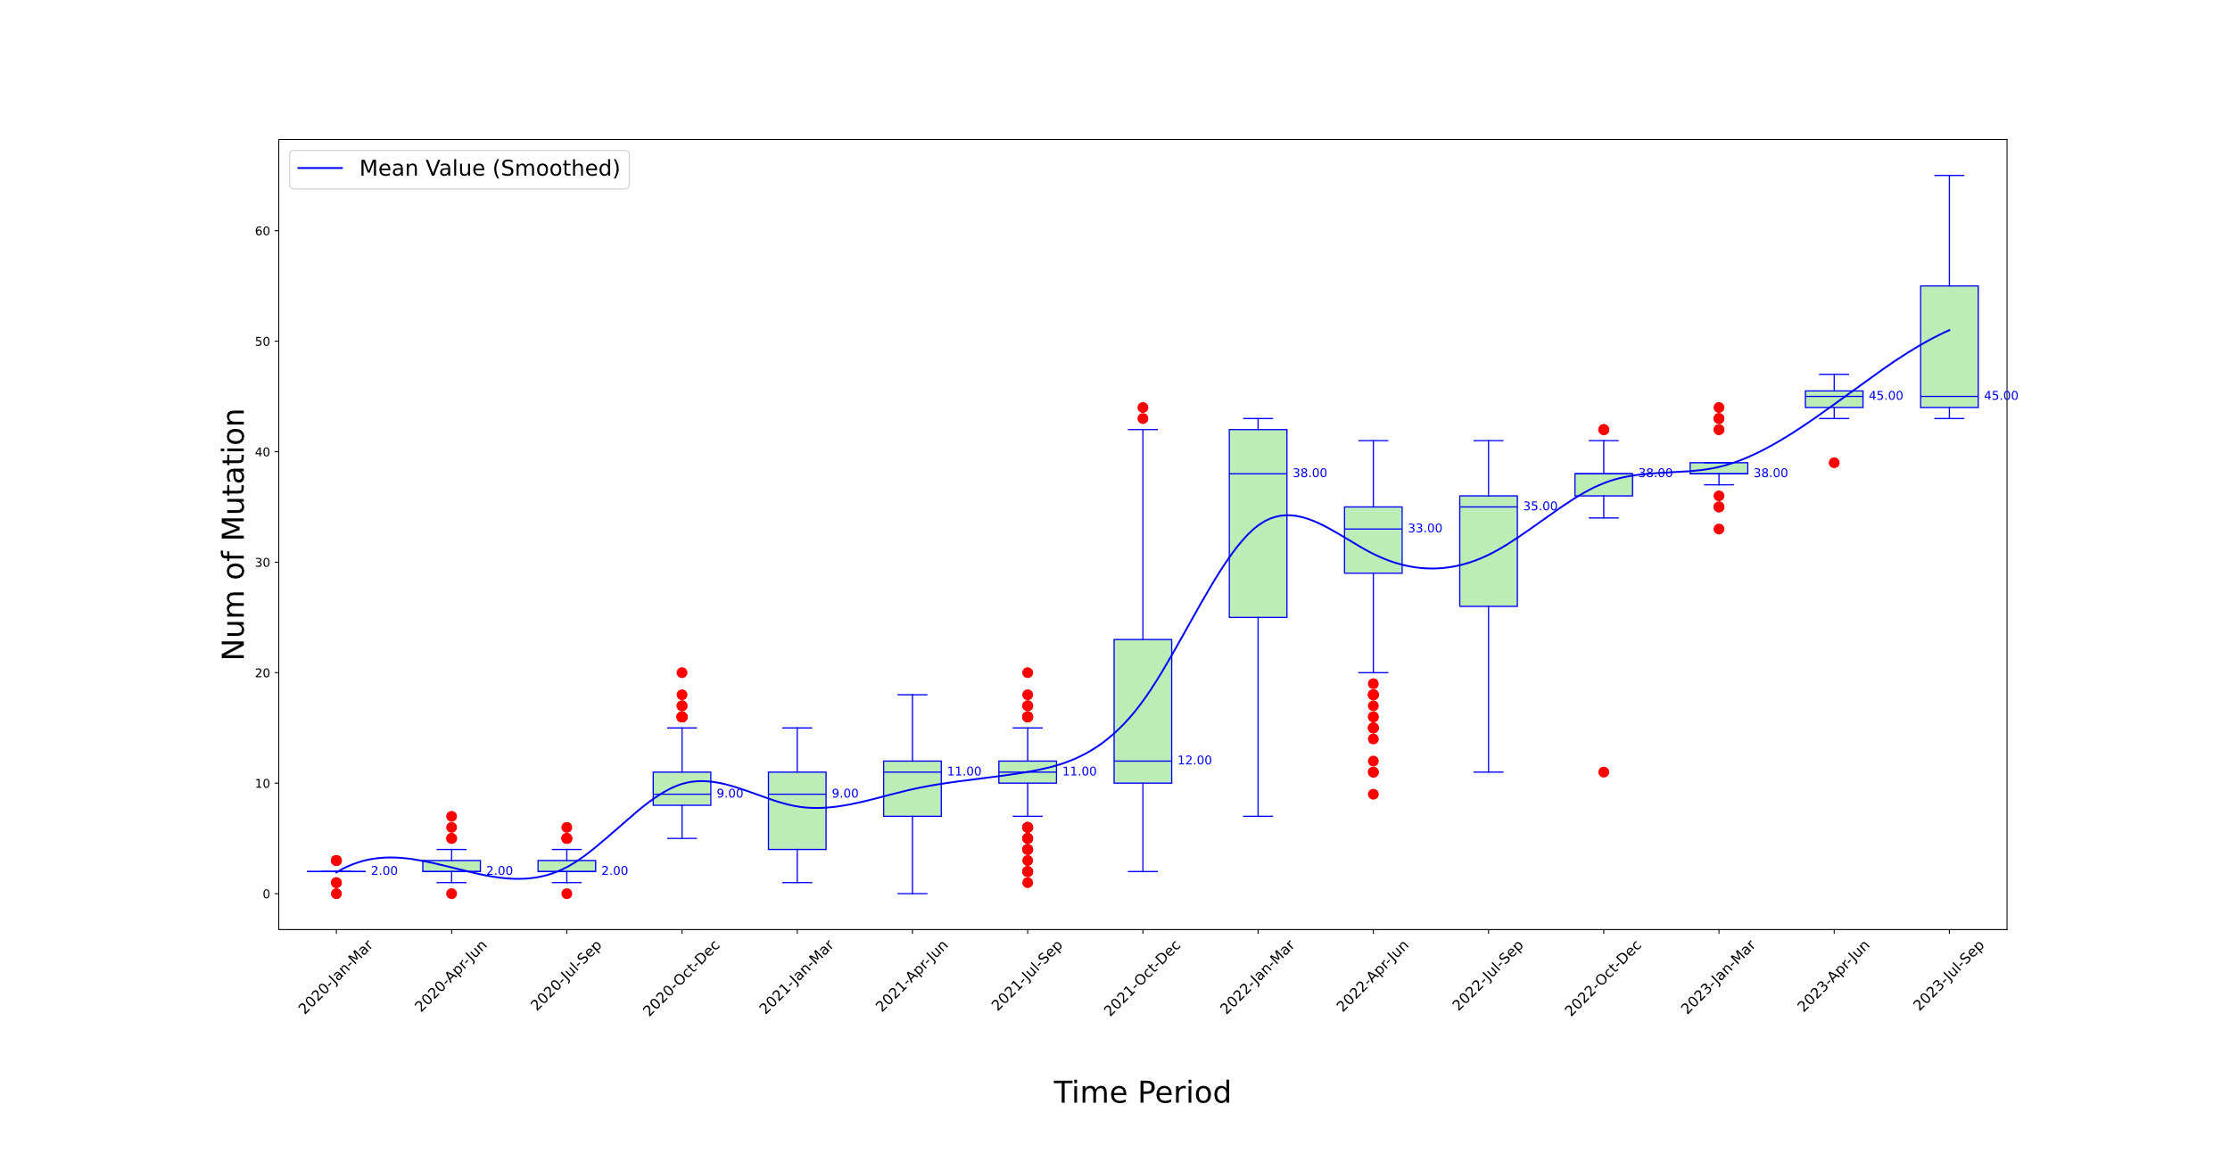

Figure S1 Temporal analysis of mutational frequency per variant sequence in Africa from 2020 to 2023

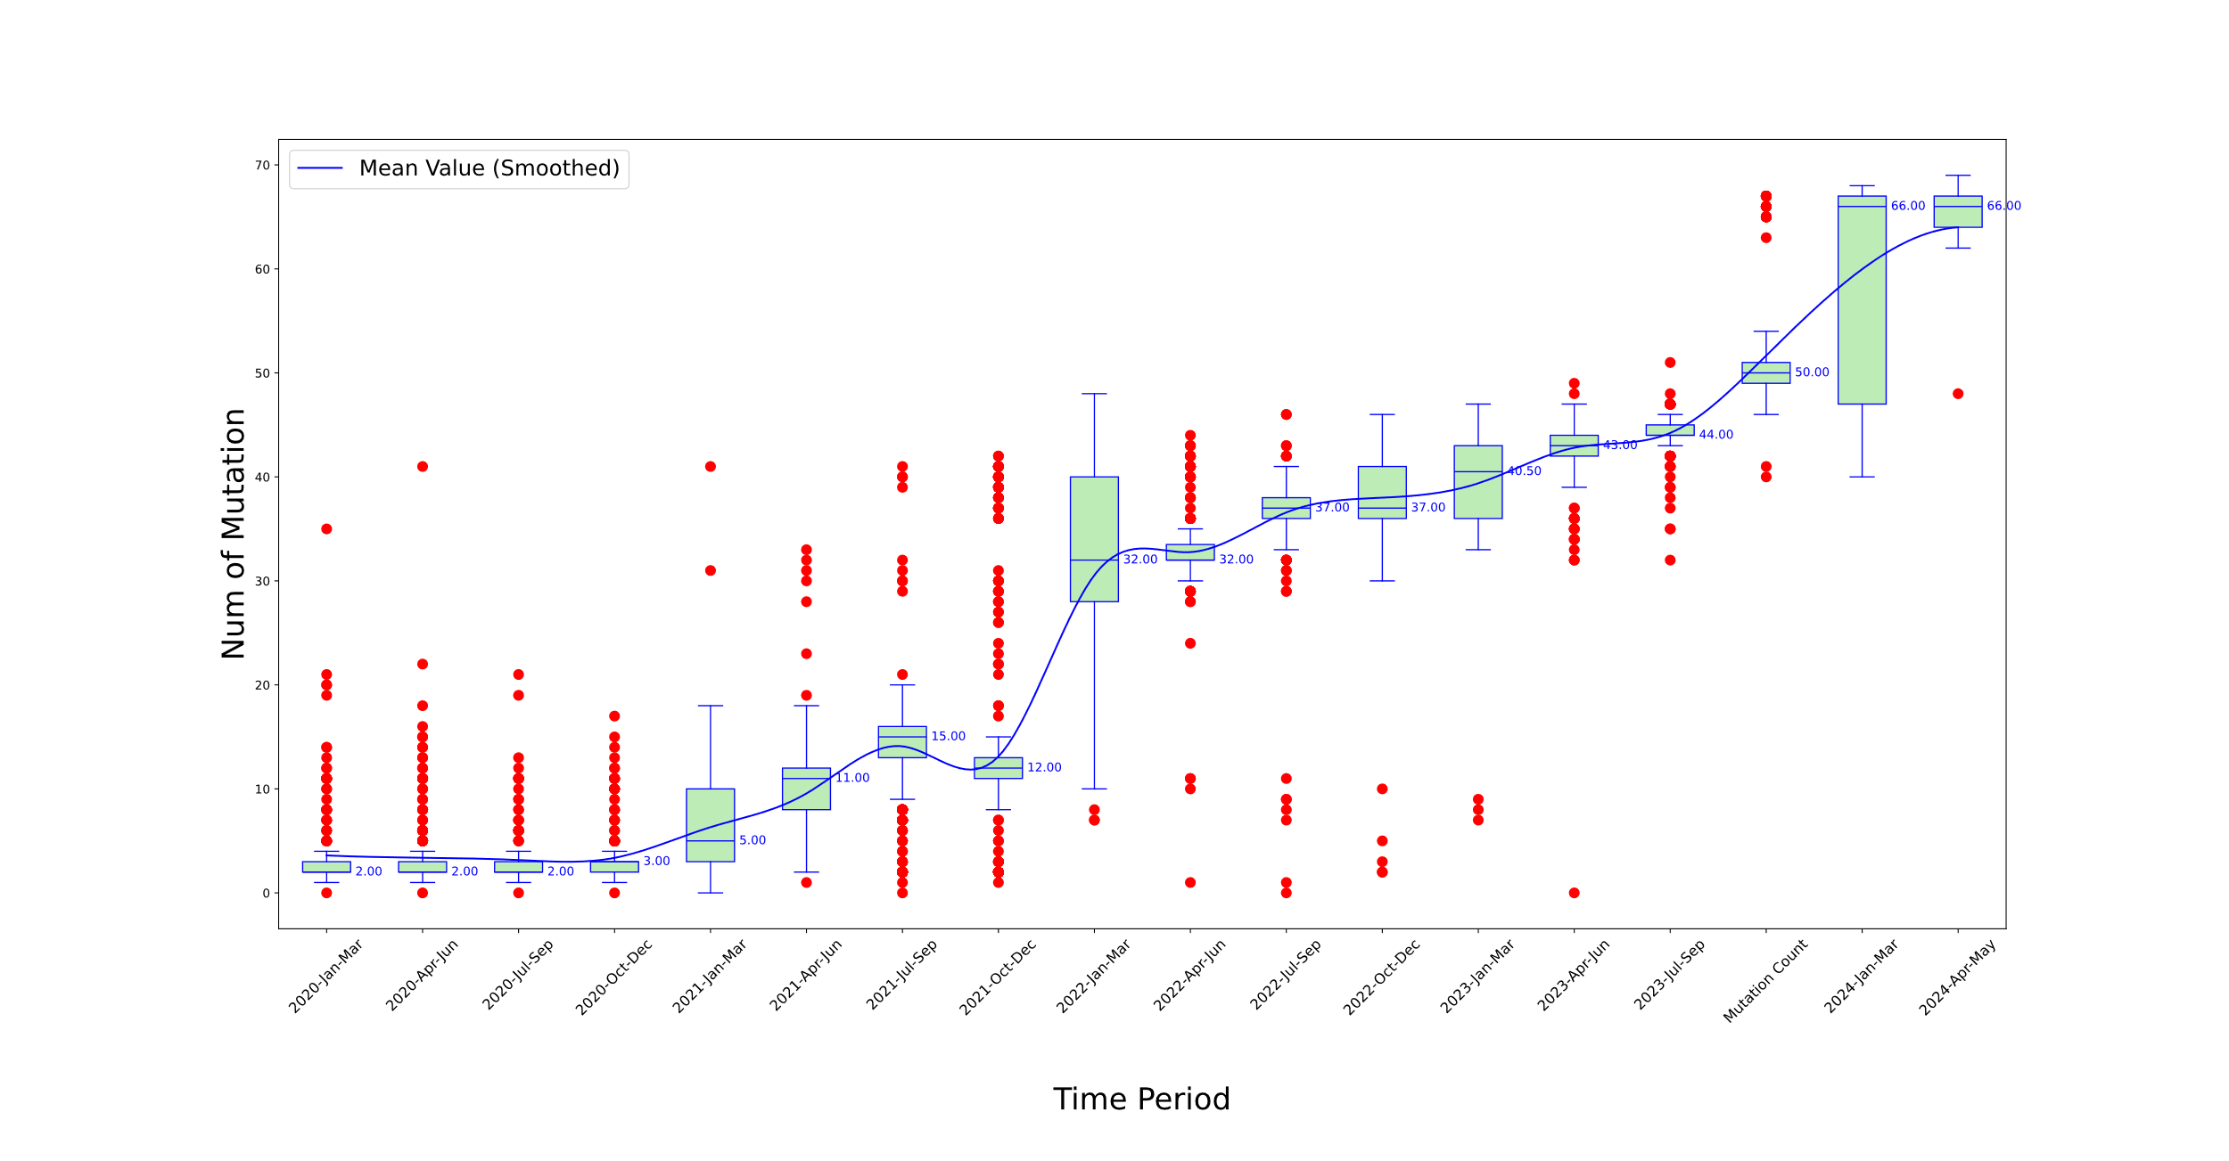

Figure S2 Temporal analysis of mutational frequency per variant sequence in Asia from 2020 to 2024

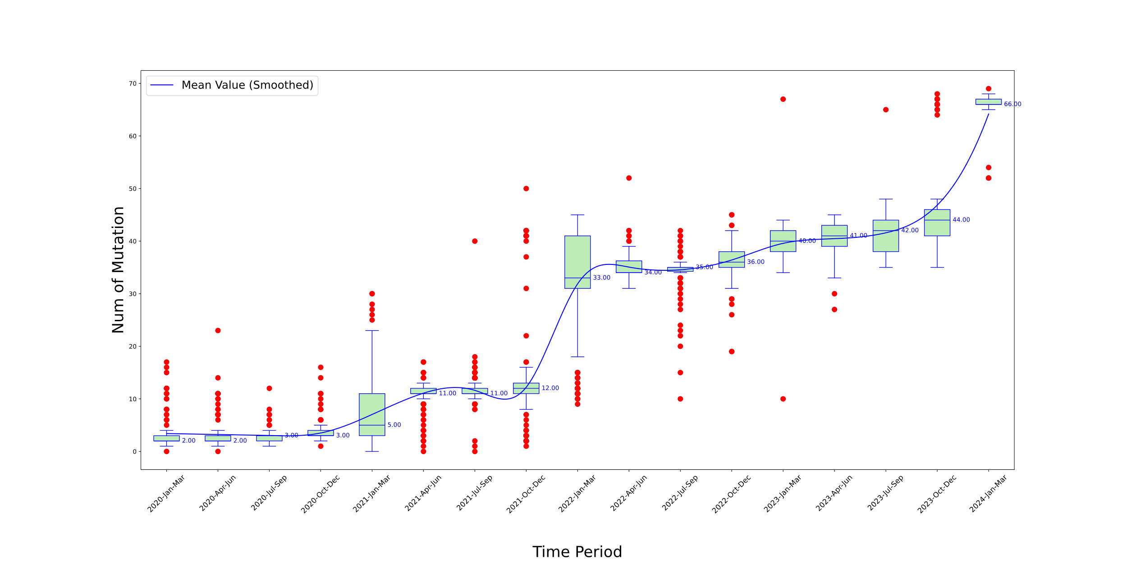

Figure S3 Temporal analysis of mutational frequency per variant sequence in Europe from 2020 to 2024

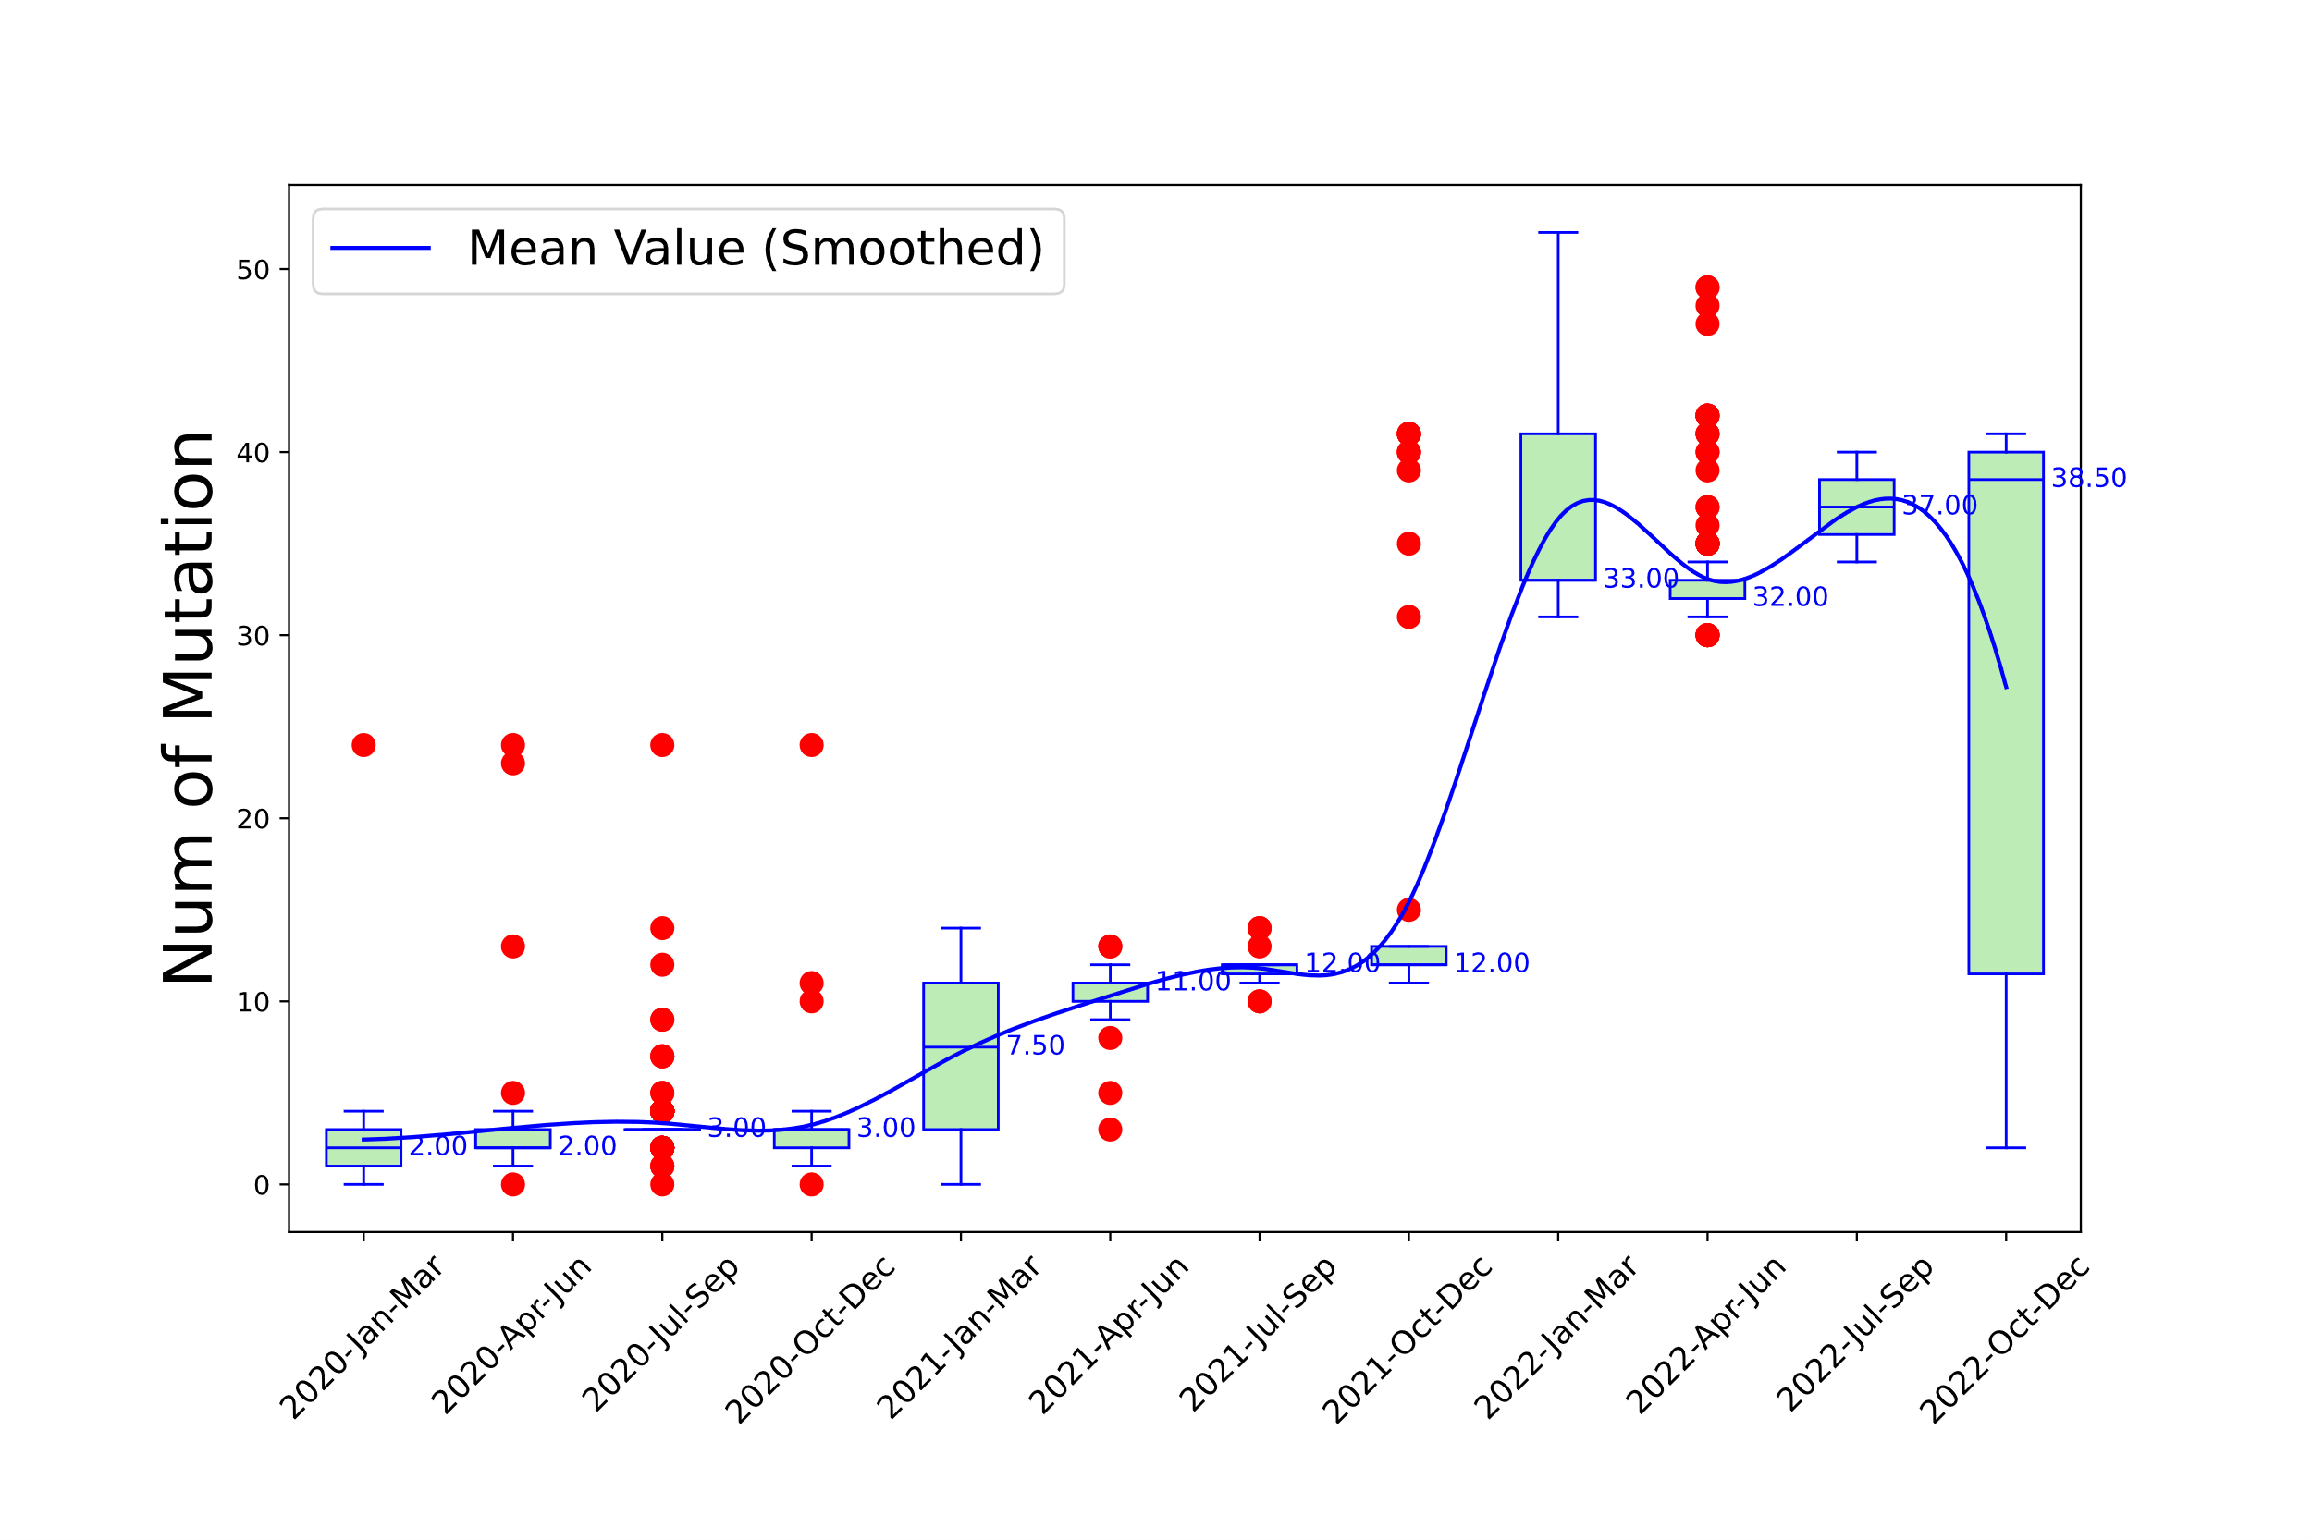

Figure S4 Temporal analysis of mutational frequency per variant sequence in Oceania from 2020 to 2022

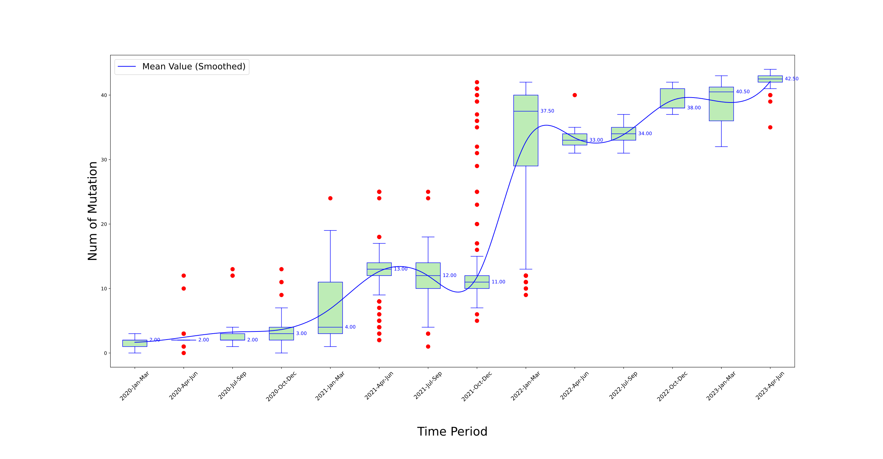

Figure S5 Temporal analysis of mutational frequency per variant sequence in South America from 2020 to 2022

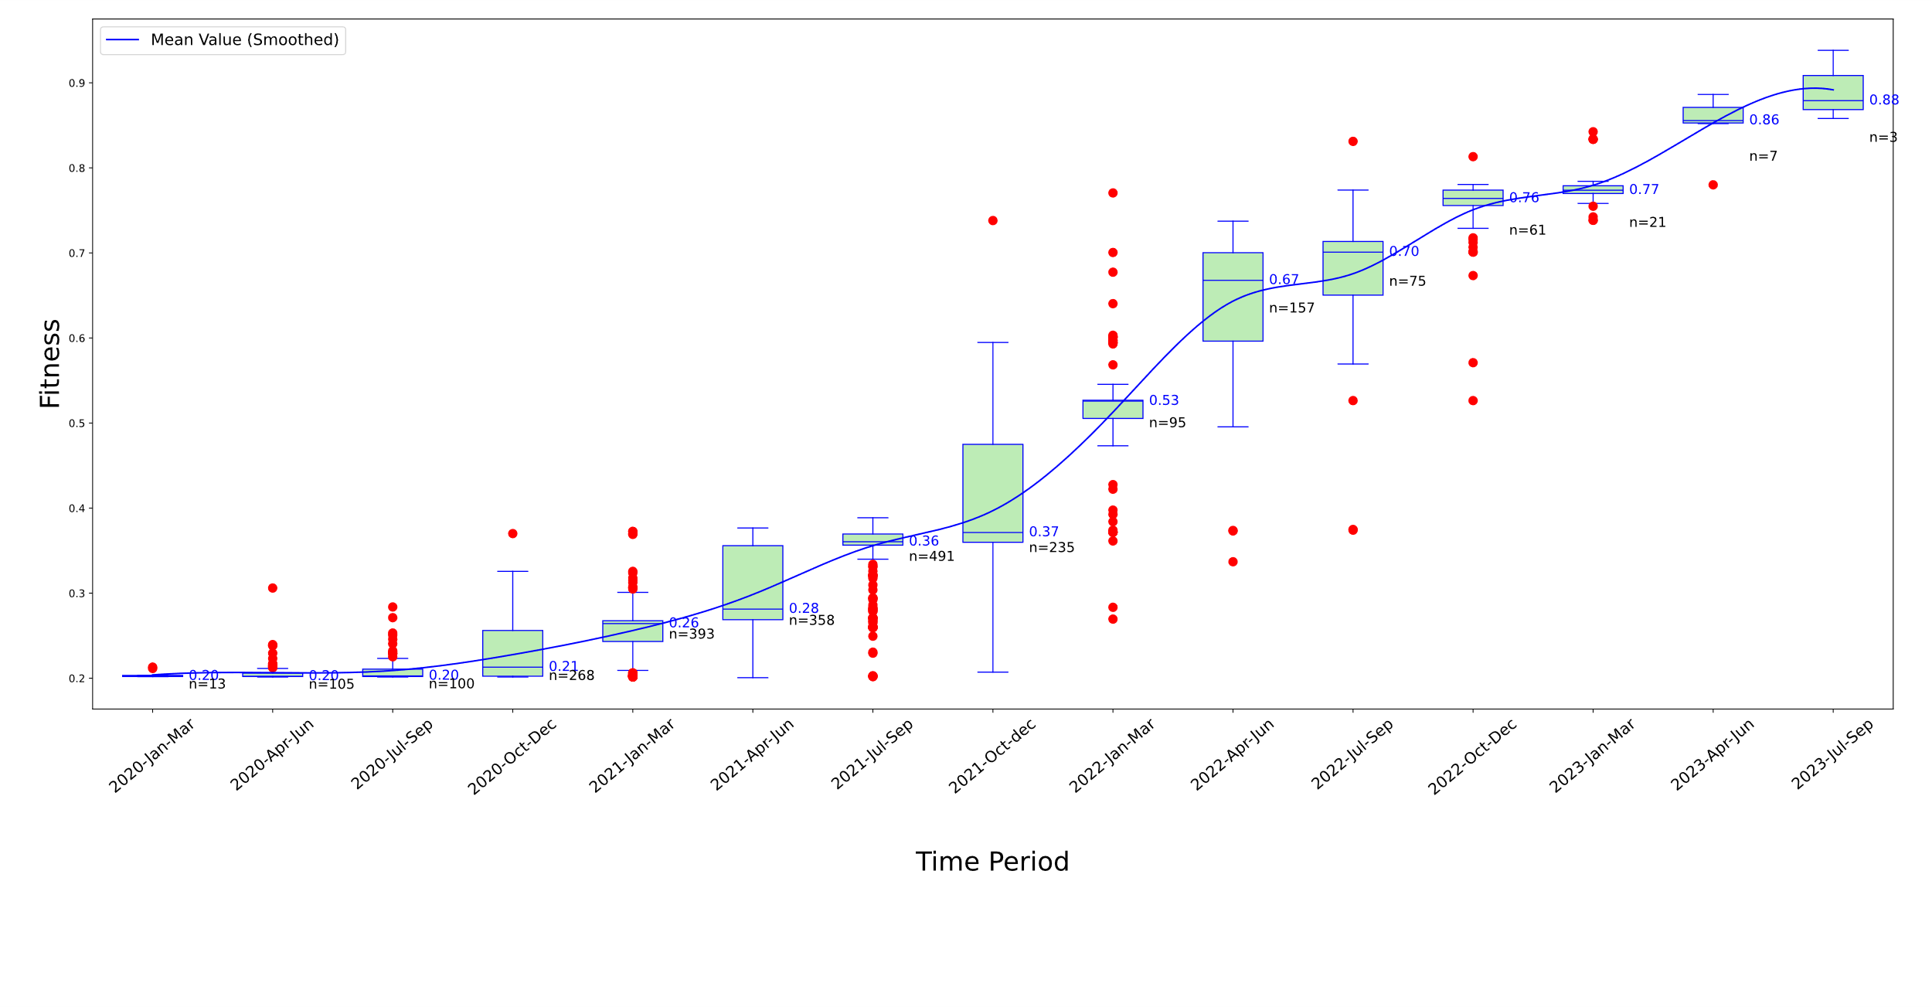

Figure S6 Temporal analysis of Fitness levels for S protein variants in Africa over various time periods

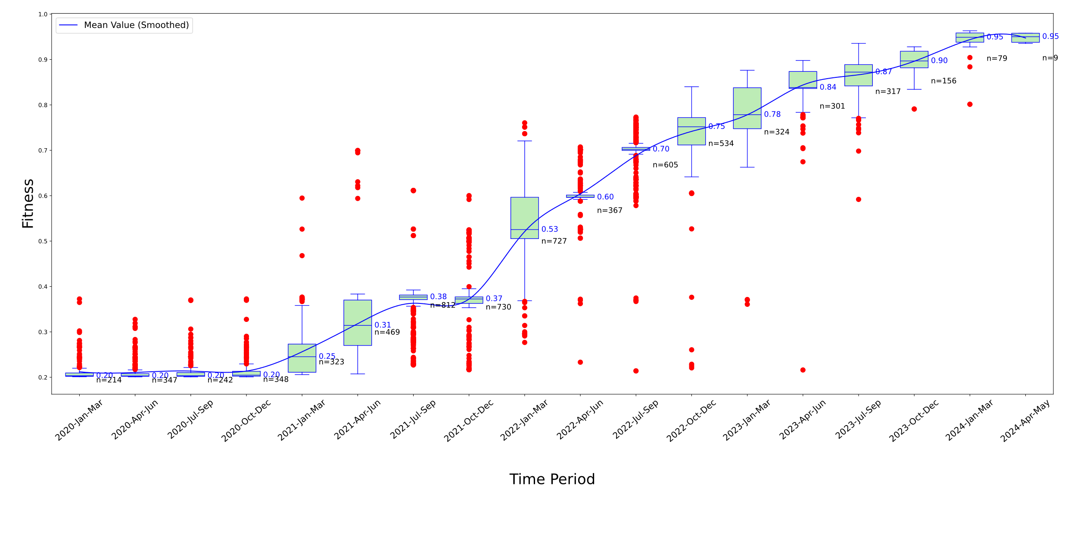

Figure S7 Temporal analysis of Fitness levels for S protein variants in Asia over various time periods

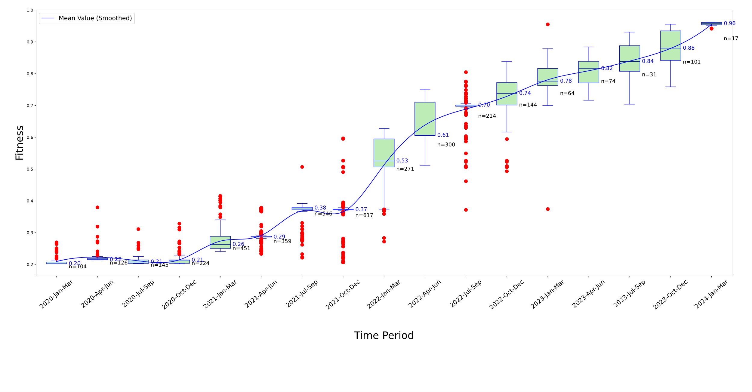

Figure S8 Temporal analysis of Fitness levels for S protein variants in Europe over various time periods

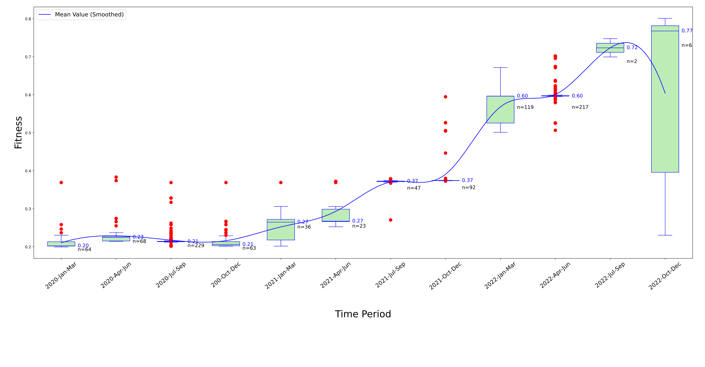

Figure S9 Temporal analysis of Fitness levels for S protein variants in Oceania over various time periods

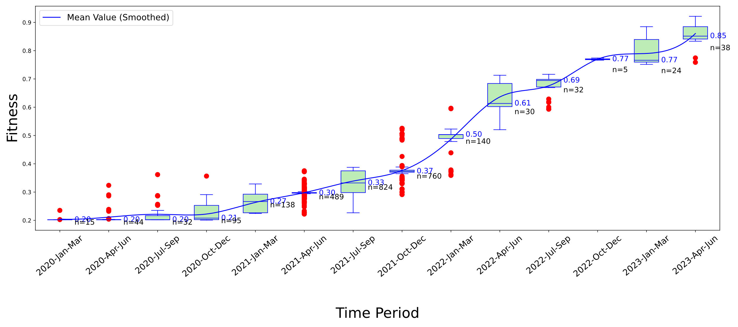

Figure S10 Temporal analysis of Fitness levels for S protein variants in South America over various time periods

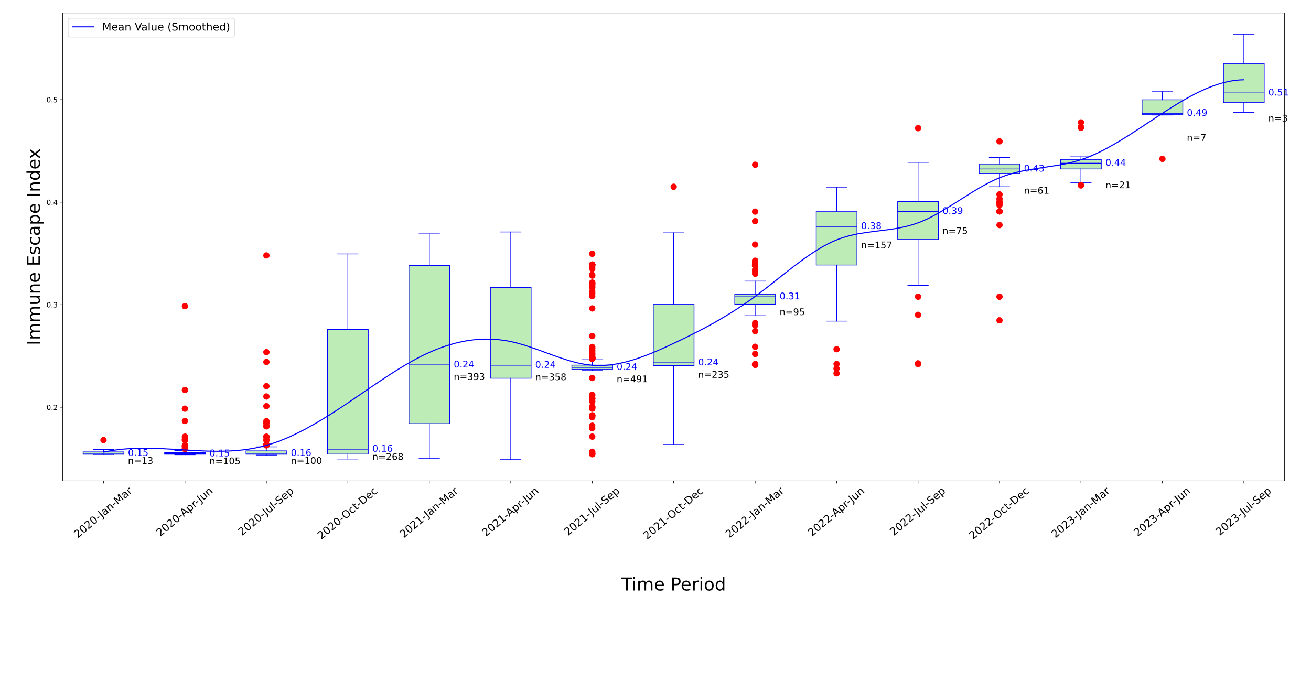

Figure S11 Temporal analysis of Immune Escape Index for S protein variants in Africa

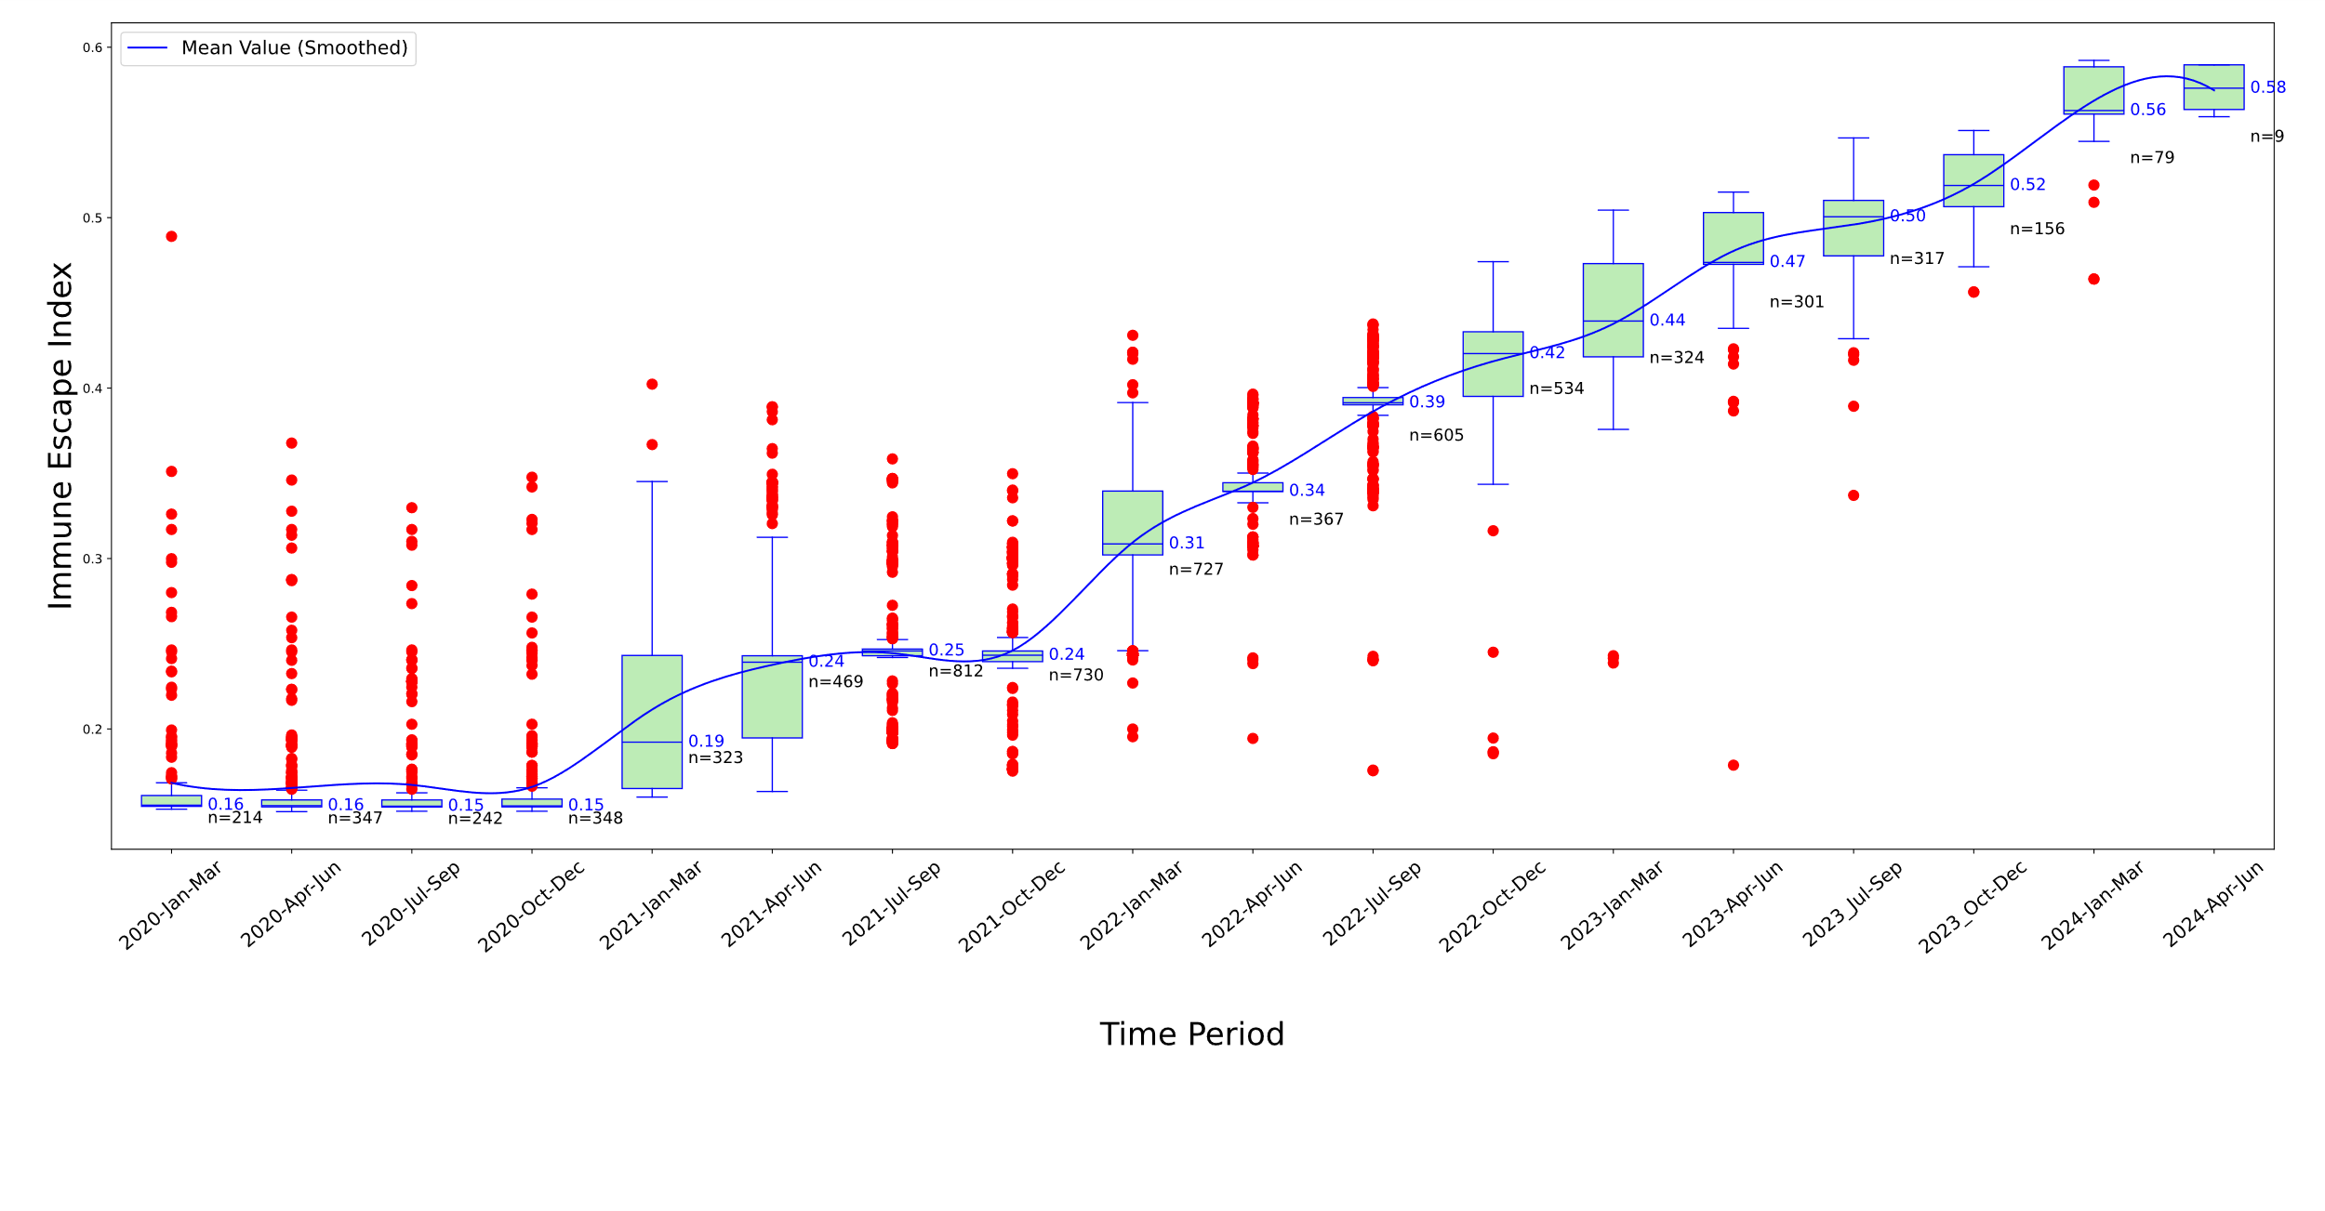

Figure S12 Temporal analysis of Immune Escape Index for S protein variants in Asia

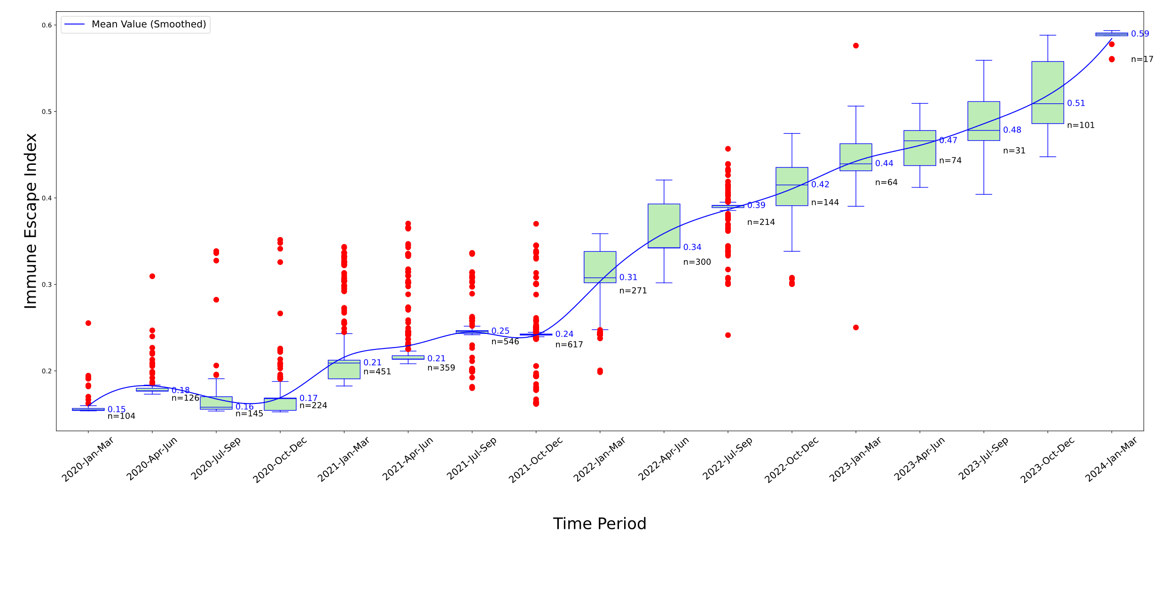

Figure S13 Temporal analysis of Immune Escape Index for S protein variants in Europe

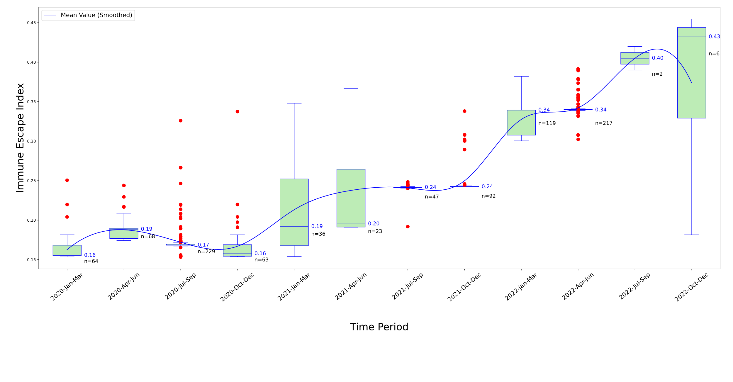

Figure S14 Temporal analysis of Immune Escape Index for S protein variants in Oceania

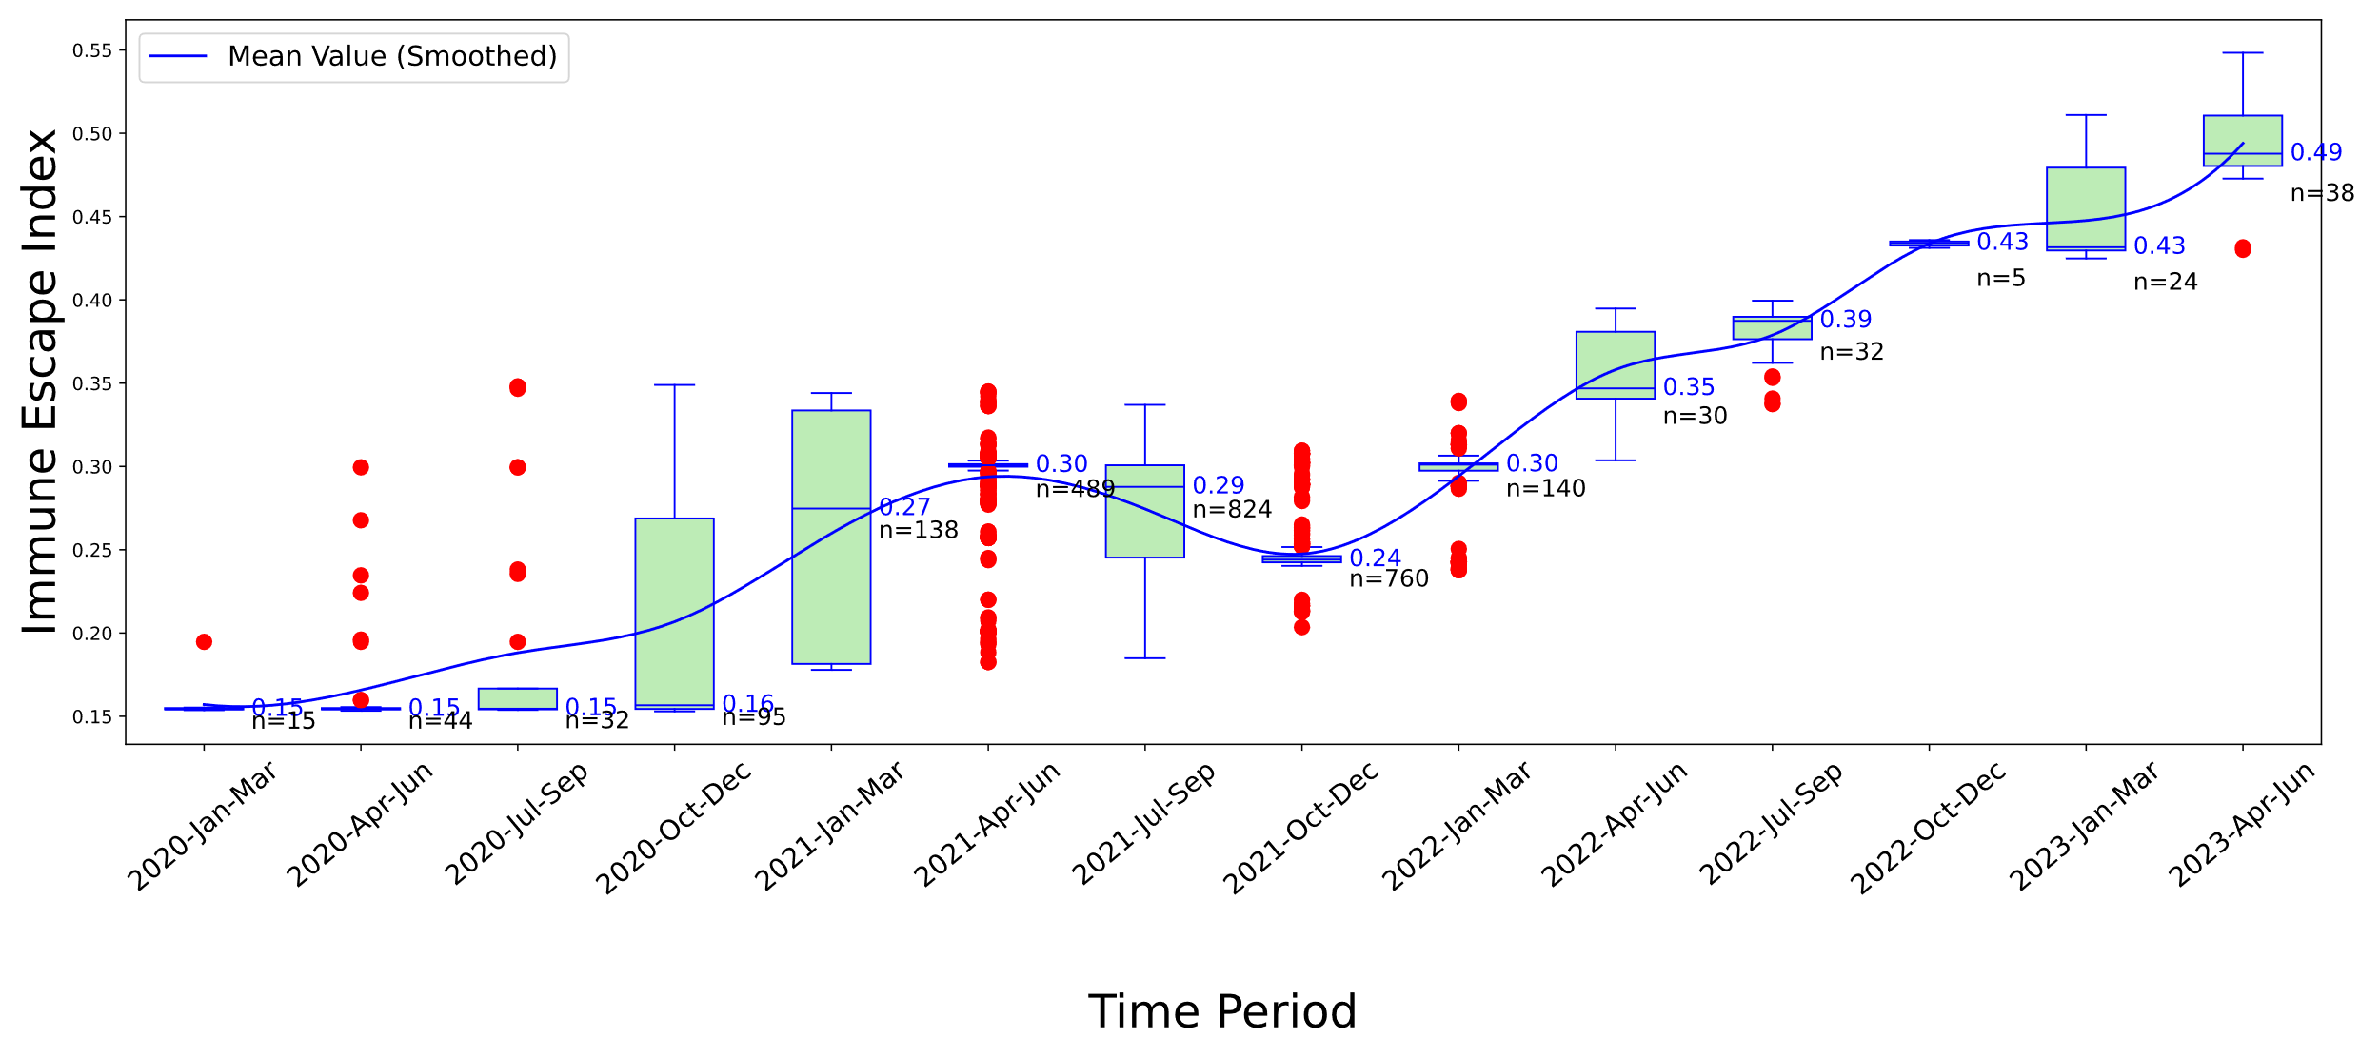

Figure S15 Temporal analysis of Immune Escape Index for S protein variants in South America